Exploring Genetic Variation in a Caffeine Metabolism gene
LAB FOUR: AGAROSE GEL ELECTROPHORESIS

Purpose: In this laboratory, we will examine the results of your RFLP using agarose gel electrophoresis.
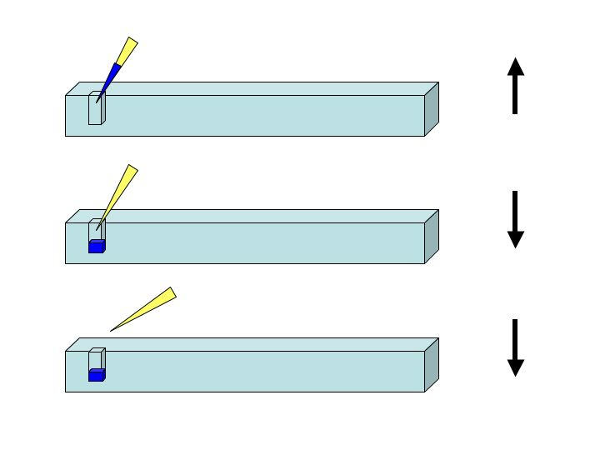Figure 2. How to load an agarose gel. Once your sample is in the tip, submerge the tip in the buffer and put it gently into the well. Push the sample out of the tip (go down to the hard stop). Keep your thumb down until you remove the tip from the liquid. Otherwise, you will suck water back up into the tip. The arrows on the right indicate the direction of the plunger at each point.
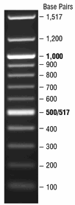Figure 1. 100bp DNA ladder. The number of base pairs, or the size of the DNA fragment, is indicated at the right.

Background
In order to see that the particular gene fragment we want has been amplified by PCR and subsequently cut by restriction enzymes, it is necessary to determine the size of the DNA. The most common method is DNA agarose gel electrophoresis. With the consistency of Jello, agarose is actually a molecular sieve filled with pores. Small fragments of the DNA can move quickly through the pores, while large pieces take more time. The pattern in figure 1 demonstrates that larger pieces of DNA such as the fragment that is 1517 base pairs stays near the top of the gel as contrasted to the smaller fragments of 100 base pairs at the bottom. DNA has too little mass to separate by gravity; instead, an electrical current is applied to the gel to force the DNA in one direction. The phosphate groups in the DNA backbone are negatively charged, and therefore, the DNA will only move toward the positive electrode.

Ethidium bromide is an orange dye used to stain the DNA, and it becomes fluorescent after excitation with UV light. Ethidium bromide is considered a carcinogen. Though it does not directly mutate DNA, it does insert between the DNA base pairs, interfering with normal DNA replication.

By comparison to a set of DNA molecular weight standards (or ladder, see Figure 1) loaded in the same gel, it is possible to accurately determine the size of DNA fragments in a sample of unknown composition, such as your RFLP samples. When dealing with nucleic acids, we examine size in terms of number of base pairs. You should be able to determine the size of your DNA fragments by comparing them to the size of the standards in the ladder. Hopefully, your DNA sizes will match your predictions from the concept check questions in lab three.

Procedure: Load the Gel
- Add 6µL of DNA loading dye to each of your three tubes using a new tip each time.
- Using figure 2 for guidance, load 20µL of your sample into a new well in the gel in the following order from left to right: 0, S, A. Keep track on the board where your samples are.
- I will load a ladder into each row of samples.
- Run the gel at 150 volts until the blue dye is about ¾ down the gel.
- Image the gel on the UV light.

Concept Check
Everyone has two CYP1A2 genes (one copy from mom and one copy from dad). Thus, individuals may be homozygous for either allele 1 or 2 (have the same allele type from both mom and dad), or heterozygous (have two different alleles). Your PCR samples should contain an equal mix of amplified CYP1A2 sequences from both your paternal and maternal alleles. Below are three agarose gel diagrams. Sketch the sizes of CYP1A2 restriction fragments that you would expect to observe based on the possible genotypes indicated.

Homozygous Allele 1 Homozygous Allele 2
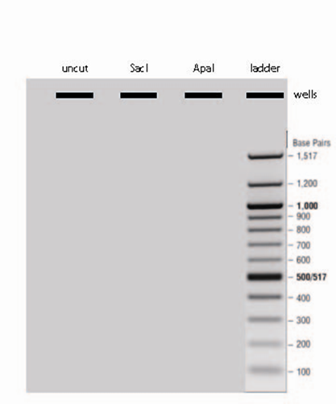
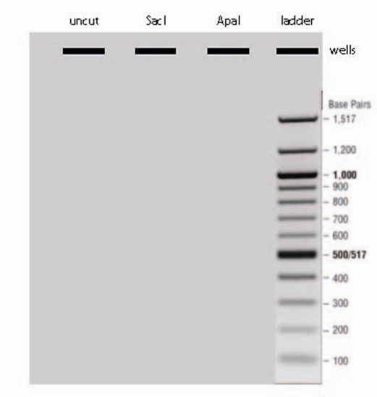

Heterozygous

Analysis
Finally, it is time to determine whether you are a fast or slow caffeine metabolizer based on this RFLP analysis. Those who are homozygous for allele 1 are considered fast metabolizers. Those who have a C in either allele are considered slow metabolizers. (It is important to note that this single experiment is unlikely to tell us the whole story, as multiple genes and environmental factors have been demonstrated to play a role. However, this single experiment may match your predictions based on your behavior and daily caffeine consumption.)
1. Does your data set indicate that you are a fast or a slow metabolizer of caffeine? _________
2. Are you a homozygote or heterozygote? _________________________

Challenge Question
Dominant alleles define the phenotype, or physical characteristics, when only one copy is present. Recessive alleles require two copies to demonstrate the phenotype. For example, people who have six fingers only need one copy of that gene to have the physical characteristic of six fingers so that gene is dominant. In contrast, those of us who have only five fingers have two copies of the same gene so the gene for five fingers is recessive.
3. Based on the information presented above, which phenotype would you predict is dominant, fast or slow? ______________
4. Which is the dominant allele (C or A SNP)? _________________
5. Which is the recessive allele (C or A SNP)? __________________

